INSTALL MVN ON UBUNTU

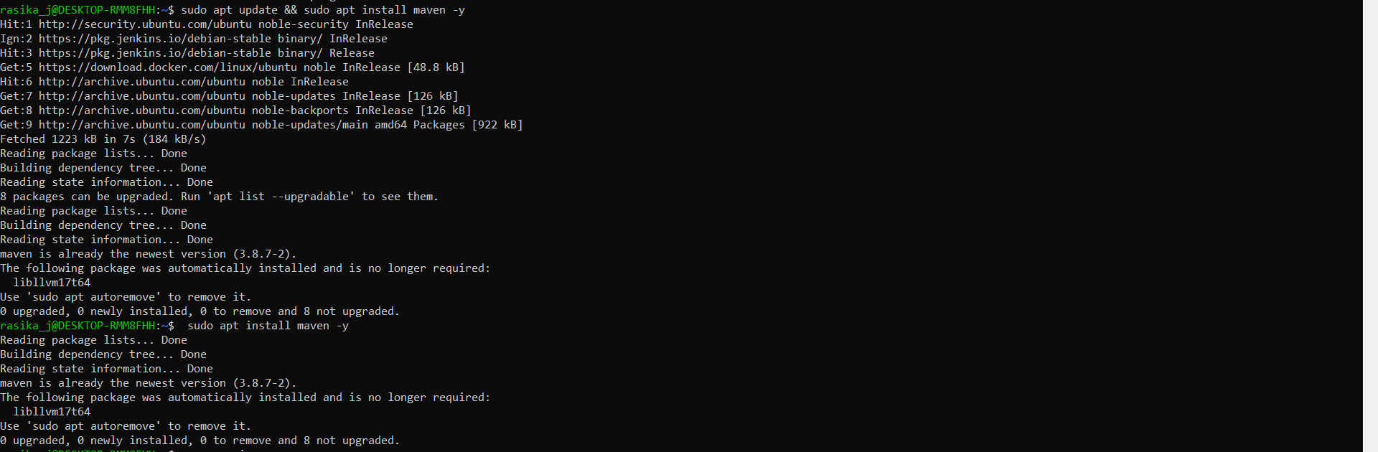

MVN VERSION

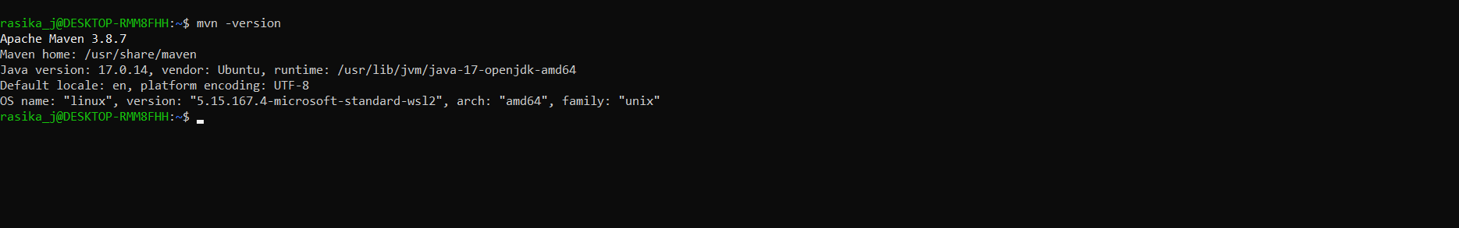

INSTALL JDK

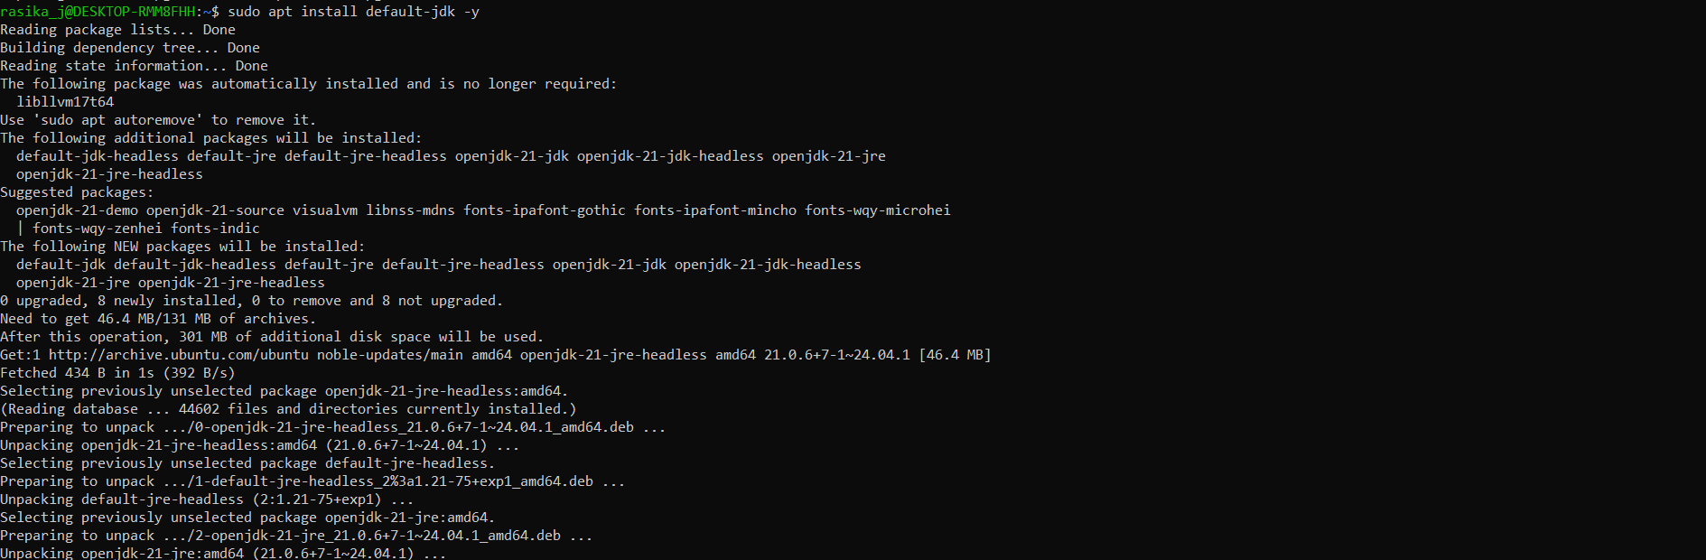

JAVA VERSION



CONNECTING TO APACHE ORG

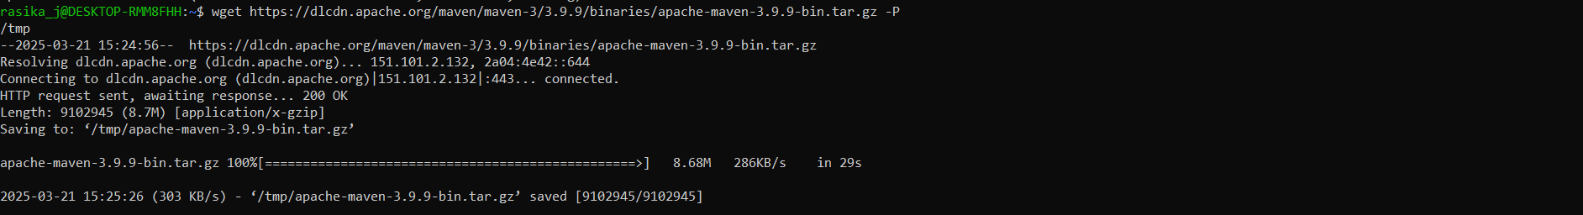

JENKINS STATUS

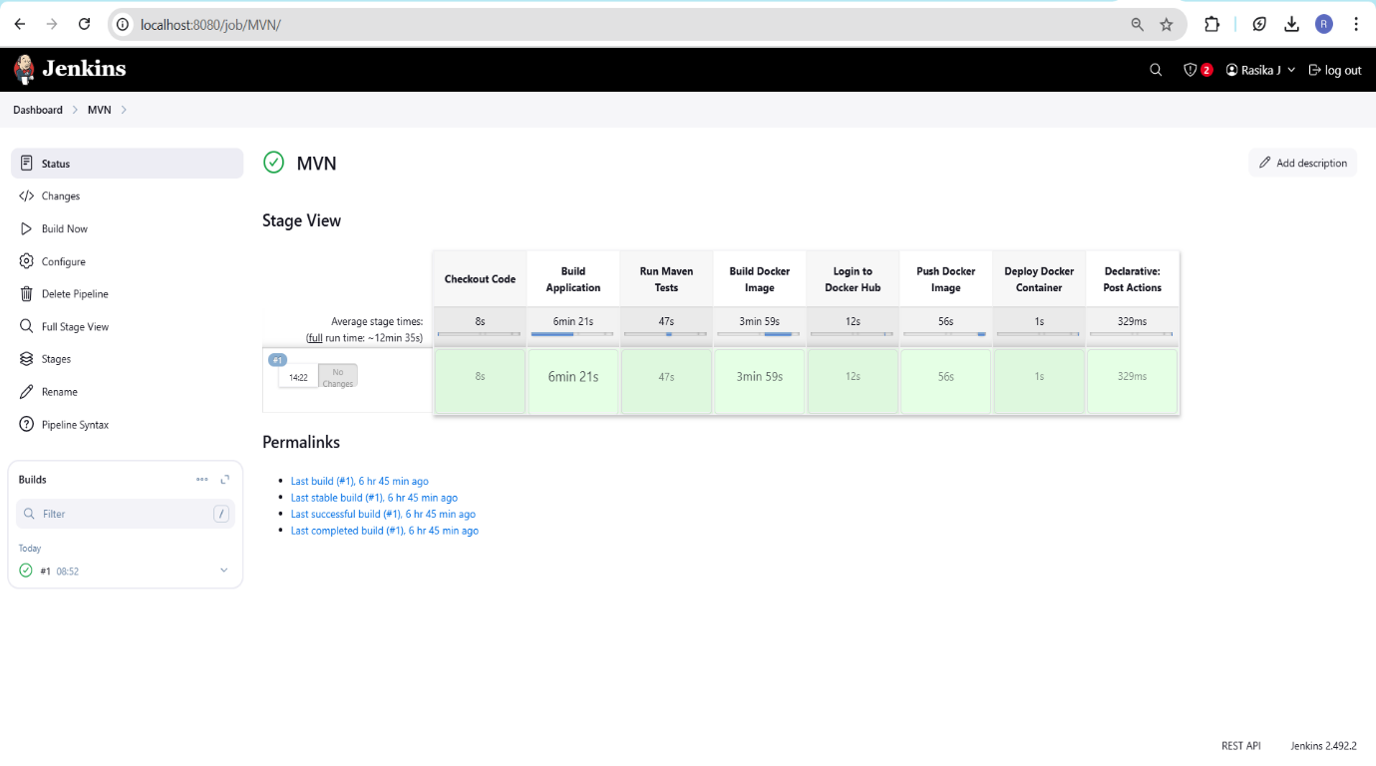

JENKINS CONSOLE OUTPUT

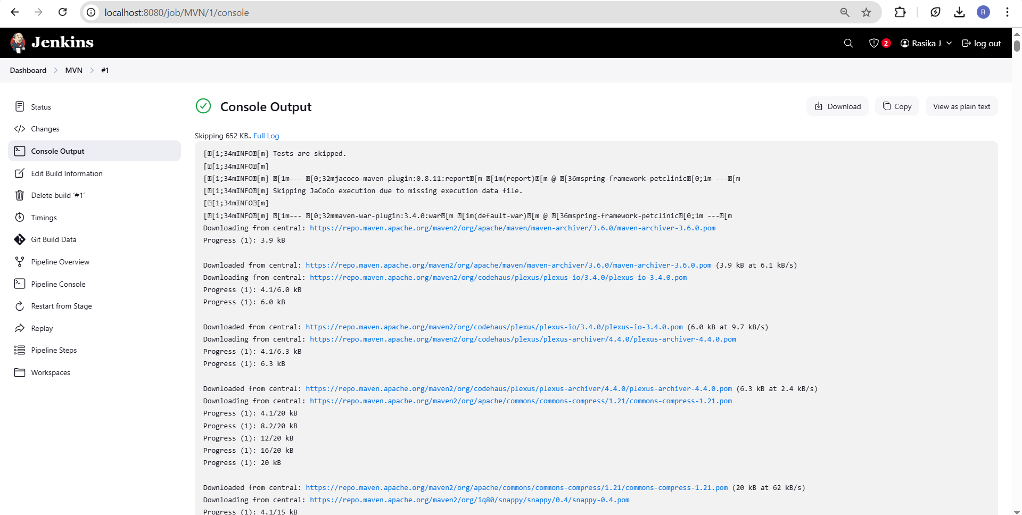

DEPLOYMENT SUCCESSFULL

